# **REPORT**

# **OOP PROJECT : SBS**

Group member: Hoàng Minh

Date: 6/1/2021

Score:__________

1. **App Function**

Picture 1: Log in

Picture 2: Sign up

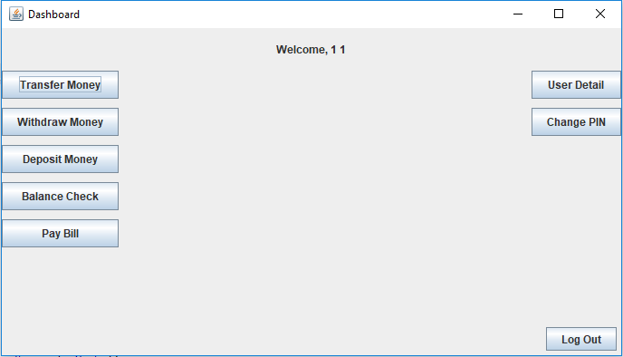

Picture 3: All functions

1. **Class Diagram**A picture containing text, receipt

   Description automatically generated

**III. DEMO**

* **Show in class**